Assigning custom conversion pairs
The assignment of arbitrary conversion pairs could appear tricky initially and something you would have to sit down to get right. The conversion direction, or then CONV_HP setting complicates it further: Here the steps to assign a custom conversion pair to MyMenu, from light years to beard seconds, just as a silly example:
First step in this tutorial is to clear the user menu, to demonstrate assigns:
KEYS: 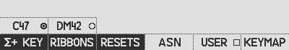 RESETS: 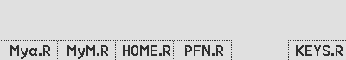
👇
👇
Reset MyMenu by opening the KEYS menu and navigating to the RESET menu and press MyM.R.
👇
CONV: 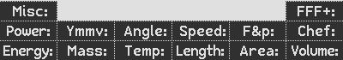
👇
Open the CONV menu


Find beard seconds in the FFF+: menu and light years in Length: menu and assign (ASN) the desired unit combination into the user menu using the keypress sequence below:
Default:
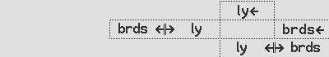

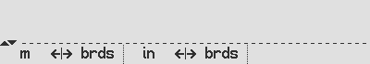
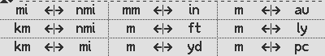
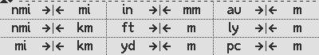
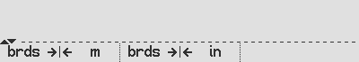
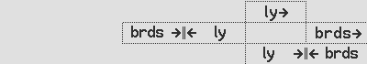
Light year: ASN Length: fF6 fUSER gF5 ASN gF5 F5 ASN F5 fF4
Beard seconds: ASN FFF+: F4 fUSER fF6 ASN fF6 F6 ASN F6 fF3
Beard seconds: ASN FFF+: F3 fUSER fF6 ASN fF6 F6 ASN F6 fF3
Light year: ASN Length: fF5 fUSER gF5 ASN gF5 F5 ASN F5 fF4

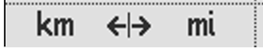

You may want to decide on which conversion direction you like, as it is could be either from a unit, or to a unit, referring to the key you press. Some prefer the non-HP way, some the HP way. By practical example, I illustrate the conversion key sequence by converting 8.5 miles to km:
👇
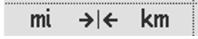
- HP (default): press 8.5 gives 13.68 km: “I want km”.
👇

- Non-HP way: press 8.5 gives 13.68 km: “I have miles”.

CFLG: 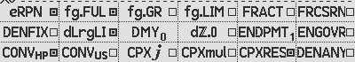 CFLG: 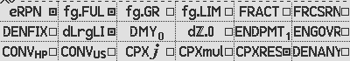
The default CONV_HP setting is set. Alternative way: clear the CONV_HP setting.

